PACKAGE MANAGERS

NEED FOR PACKAGE MANAGERS ?

To understand the need of package managers, one needs to understand how software was installed in a Linux machine before package managers came into picture.

Earlier, s/w were provided via mailing lists or ftp. Very few files contained instructions to create a binary or executable file. The steps (usually in tar files containing a readme or something) included : 1. Untar the files, 2. Follow the steps in readme and, 3. With any form of compiler run the following script, ./configure along with a list of attributes like, pathing to library files,destination(location) of new binaries created, etc.
This configure script would also check for system dependencies. If any major dependency would be missing, the configure process would terminate there and would not allow to continue the further process until all the major dependencies are met.
Once the dependencies are met, the configure process completes, a Makefile is generated.
Next step would be to run the “make” command. This command is provided with whatever compiler one is using on his system. The “make” command provides you with a bunch of flags, the make flags. With the help of such flags, the binary files to be generated could be optimized.
The last step, after successful completion of binary files creation, would be to run “sudo make install” command to perform installation of the software.

This was how a software was installed before the emergence of package managers.

As we can understand from the discussion above, installing a software in these steps is a Time-consuming and a very tedious task. Also, updating a software was in itself a very complex process this way.
So, to avoid such obstacles, a package was created. Packages allowed easier portability and reduced storage space by clubbing together multiple data files in a single archive file. Package also consisted of metadata, such as the software’s name , it’s version information and also the dependencies list which were required to run a particular software properly.

Package Managers
Package managers are used to interact with software repositories.

RPM - based package managers.
- YUM -(enterprise)
YUP(YellowDog Updater) was developed for installing YellowDog Linux. Duke University people modified it to YellowDog Updater,Modified (YUM).
- DNF -(community)
Dandified YUM is an improvised version of YUM. But has not been adapted at enterprise level.
- Zypper
Zypper is mainly associated with SUSE and OpenSUSE. It has also been adopted by MeeGo,Tizen, and Sailfish OS. It’s main use is for System administration purposes tool YaST. Few users have claimed zypper to be faster than yum.
Main difference in the working of zypper and other rpm based package managers is, in the way repositories are added in the system. Zypper supports importing from repository files as well as adding repos using the package manager itself and the most common way is with the use of URLs.
Cmd : zypper addrepo “url”

Debian-based package managers

2nd Page :
Linux software applications are called packages, and package managers are software that handle the process of installing, maintaining, and uninstalling these packages.
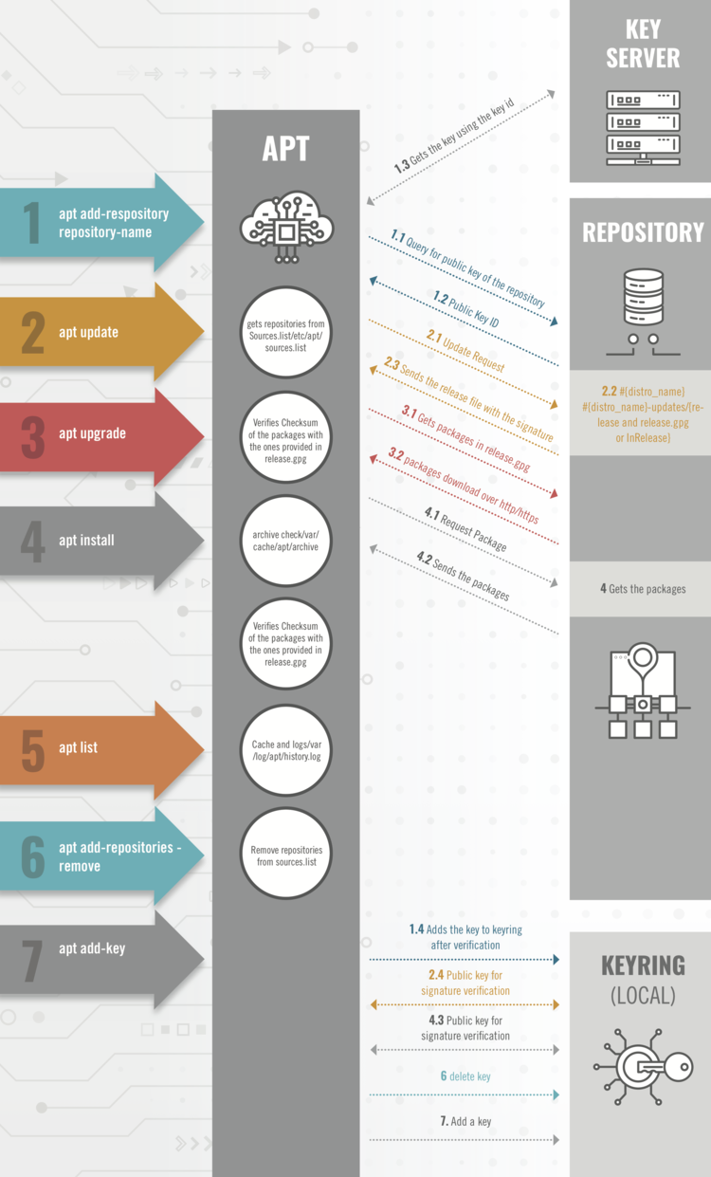

The following are three main components used in Debian architecture to maintain integrity:
- Keyserver – A central authority which holds all the public keys and signatures on those public keys. In Debian, keyring.debian.org is a keyserver, and before their key gets added into the keyserver, developers need to prove their identity and get their key signed by another developer.
- Repository – A space to host packages available to download.
- Keyring – A local storage of all the trusted keys. It includes any keys present in /usr/share/keyrings, /etc/apt/trusted.gpg, and /etc/apt/trusted.gpg.d.
When a user wants to add additional repositories, the apt add-repository command is used. The following then occurs:
- The package manager queries the repository to get the public key fingerprint.
- The package manager downloads the public key from the keyserver using the fingerprint.
- The package manager verifies the signature and adds it to /etc/apt/trusted.gpg or /etc/apt/trusted.gpg.d/.
- The repository is then added to /etc/apt/sources.list or /etc/apt/sources.list.d.

